Heat Island Research Activity

Directions: Using the following link to the website: http://www.epa.gov/heatisland/index.htm , answer the following questions. Use the menu on the left side of the screen to navigate the page.

Basic Information
- Define “Heat Island”

- Sketch the temperature variations as shown on the website onto the profile below. Discuss which
Areas are cooler.

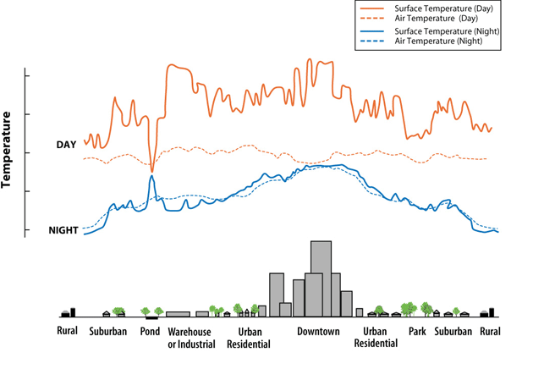

- How do heat islands form?

- Describe two methods that contribute to higher urban temperatures from heat islands.

- Discuss the environmental benefits/detriments of wintertime and summertime heat island areas.

- What is HIRI and what is its purpose?

- Describe the effects of excessive heat on human health.

- How does ozone form?

- What is the temperature difference between a green roof and a traditional roof?

- List two benefits of a green roof.

- Go to the “tools” menu on the left of the screen, and then click the “database of projects and programs”. Does PA have any mitigation listed?

